A Modular Hardware Front-End for fast Prototyping

Cyrill Lippuner

Semester Project

Laboratory of Intelligent Systems

14.1.2019

# Abstract

A modular framework taking the role as a platform in between custom sensors and actuators and third-party applications, which provides live visual feedback of the physical setup which is plug’n’playable and only requires a low level of understanding in hardware development.

Key features are the Visual Interface as well as the Fact that no hardware programming is needed to acquire data, control actuators or create offline/online closed loops. Controlling and configuration can be done from a PC which allows a much faster and more user-friendly interaction with physical devices as compared to Arduino or ROS. Further, the Framework provides an API for programmatic access for custom scripts and UDP streams for data processing.

The project was completed successfully as all initially required features are implemented and the Framework has been tested already on 3 other semester projects which heavily depend on the Framework to complete their work.

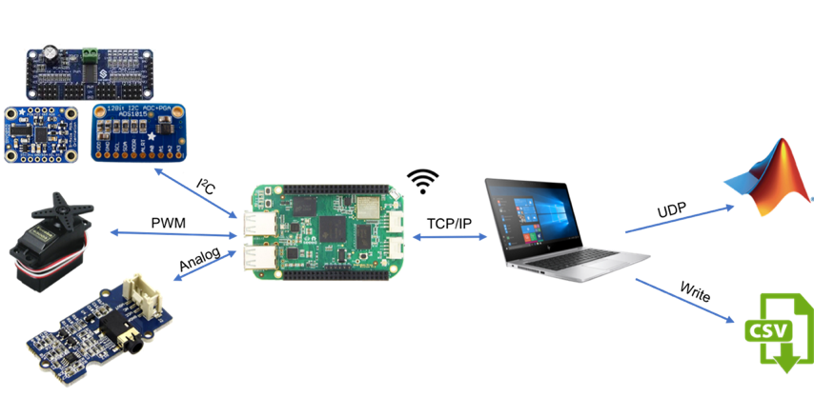

Figure 1 – Diagram of the Framework with data flow from the Sensors/Actuators through the Firmware on the Microcontroller and the Interface on the PC to Third-Party Applications